Power Board

* + Receives a 14.8V line from the backplane board.
  + Delivers five different power output to the backplane.

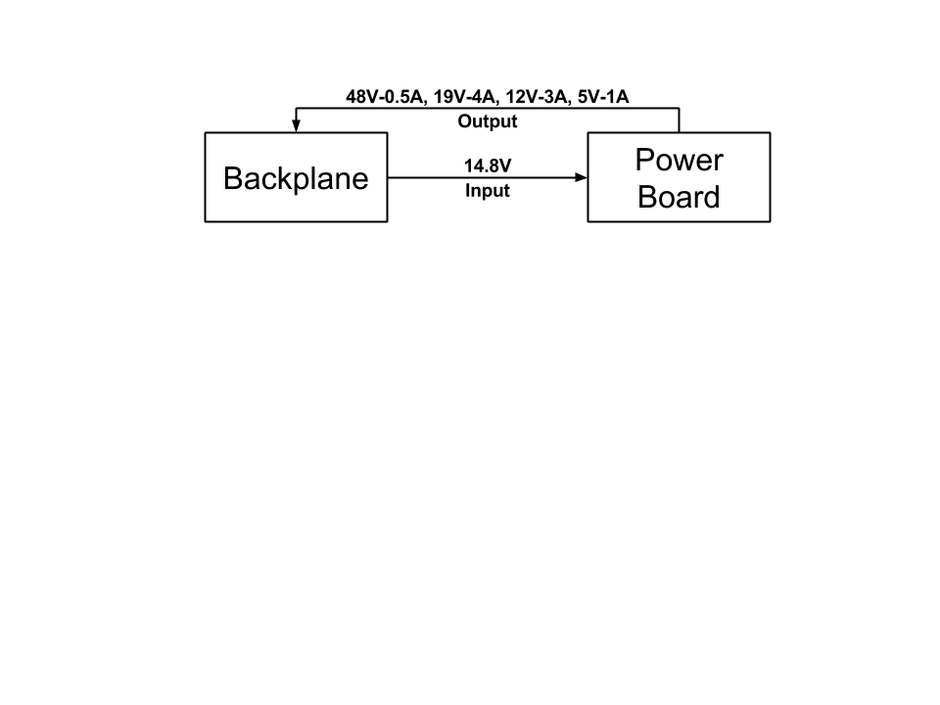

* 5V with maximum current draw of 1A for Digital components.
* 12V with maximum current draw of 3A for Electromechanical actuators.
* 19V with maximum current draw of 4A for Central Processing Unit (CPU).
* 48V with maximum current draw of 0.5A for Doppler Velocity Logger(DVL).
* 48V with maximum current draw of 0.5A for a camera through Power over Ethernet(PoE).
* Current sensing using current shunt monitors and Arduino Micro.

